Borrisokane Community College School Notes

Bond Trader Challenge
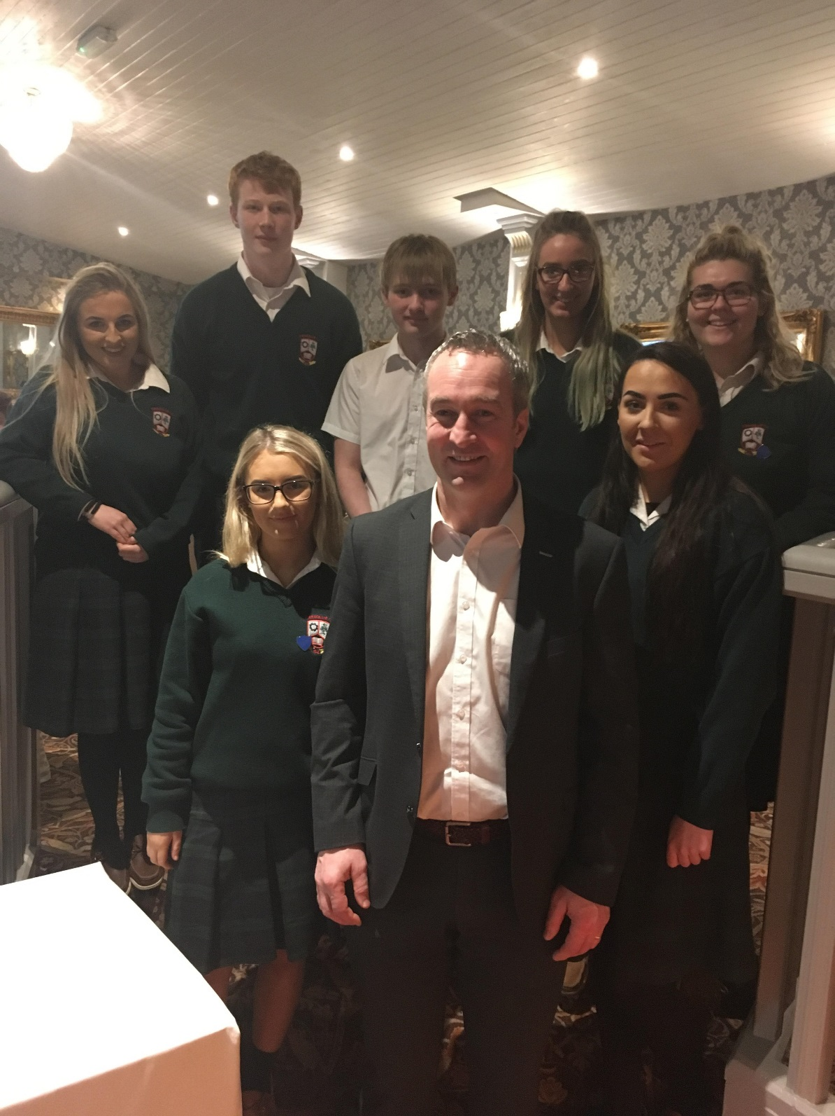
Back Row: Claire Walsh, Robert Guest, William Mooney, Aine Mounsey, Alison Claffey,
Front Row: Ellen Quigley, Michael Ryan Tipperary Hurling Manager, Catherine Tighe.
On the 17th of January, 5th & 6th year Business & LCVP students took part in the Bond Trader Challenge in the Anner Hotel, Thurles organised by the Bank of Ireland. The day began with an overview of markets and trading presented by the Bank of Ireland Head of Pensions & Investments, Mr Bernard Walsh. Students then took part in the Bond Trader Challenge. They were set the challenge of responding to real trade market scenarios and making decisions on managing their own bond portfolio. Borrisokane Community College students were delighted to come 2nd proving they had excellent economic analysis skills which they had successfully used to trade effectively in the mock scenario. The winners included Darragh Kinsella, Pearse Cahalan, William Duffy and Tommy Wells.
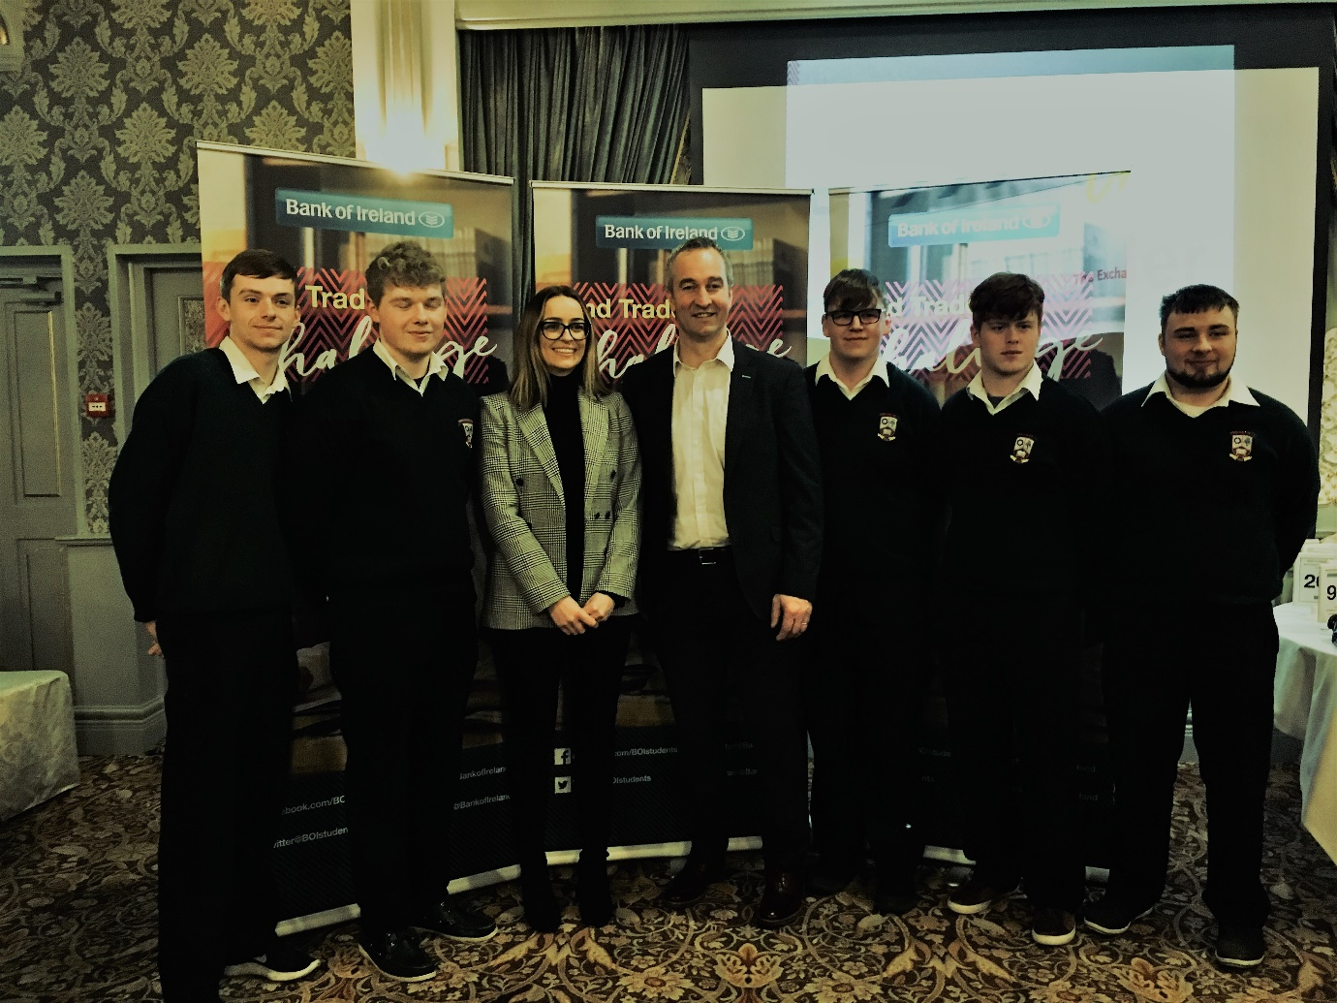
Borrisokane Community College students at the Bank of Ireland Bond Trader competition.
L to R: Darragh Kinsella, Pearse Cahalan, Elaine Dunne LCVP Teacher, Michael Ryan, William Duffy, Ben Prendergast, Tommy Wells.

#Empower your voice Student Leader Congress for Cycle Against Suicide (CAS).
On the 18th January, 49 students left bright and early from Borrisokane Community College destined for the 3 Arena. They were part of over 7,000 students partaking in the Student leader congress being hosted by the Cycle against Suicide organisation. On arrival the students were brought to the main foyer where stalls including Childline, Spunout and Bodywhys were represented. The Congress started at 10.30 am when the stage instantly was lit up by an array of colours and live music. Main headliners included Little Hours and Mundy. Our own 5th year student, Lorcan Tuohy, a student leader ambassador of CAS spoke on stage about the upcoming Schools Goes Orange event. This will take place with a range of activities being planned in the school on 23rd February. Lorcan also highlighted the importance of being active regularly resulting in good positive mental health. Those on stage sang ‘Echo’ a song written by the 13 leaders as the theme song for Congress this year.
James Kavanagh, owner of food brand Curabinny and one of Ireland’s biggest snapchat and social media influencers was also involved in the event. He spoke about his own personal experiences and challenges of being gay and coming out to friends and family. The highlight of the day was award winning global speaker US native, Kevin Hines. He spoke about his own survival from a suicide attempt. His honesty, realism, understanding and appreciation of the complexity surrounding mental illness was apparent throughout his talk. He is travelling to various countries in an attempt to eliminate the societal stigma and discrimination of suicide and mental illness. The annual trip to the CAS Congress proves an extremely informative and enjoyable day out for all students. The students are very thankful for the support of the teachers that joined them on the trip, Ms Michelle McMahon, Mr James Mc Evoy and Ms Evelyn Enright.
Eilis Ireland and Aisling Rafferty (TY students).

Senior soccer squad claim the North Munster cup
On 15th January the Borrisokane Senior soccer team faced Crescent College in the North Munster Cup. Weather condition were difficult and it was evident from early on that this was going to be a fiercely contested battle. Crescent College started the better team, however BCC were patient and held their nerve, waiting for their opportunity to pounce. After some well worked build up play Liam Cleary opened the scoring with a fine strike on 22’. From here BCC took a foothold in the game and went close on several occasions. Neil Connelly added a second on 32’ and the game looked to be slipping away from their opponents. Connelly could have had a first half hat-trick had it not been for some fine saves from the Crescents goalkeeper and a fantastic effort that went agonisingly wide. The half ended 2-0 to Borrisokane. A quick fire Crescent goal early in the second half tested the nerve of BCC who had scuffed numerous chances. After many failed attempts BCC restored their two goal advantage on 69’ when Connelly grabbed his second of the game. Cianán O hAnluain put the game beyond any doubt at 77’ with a strike from distance before a late Jack Daly penalty rewarded him for a fine individual performance. Captain Conal Moran gave a man of the match display as did Sean McAdams in defence. Well done to Mr. McGinn and his squad.

Borrisokane Senior Soccer Squad and Coach Mr Mark Mc Ginn
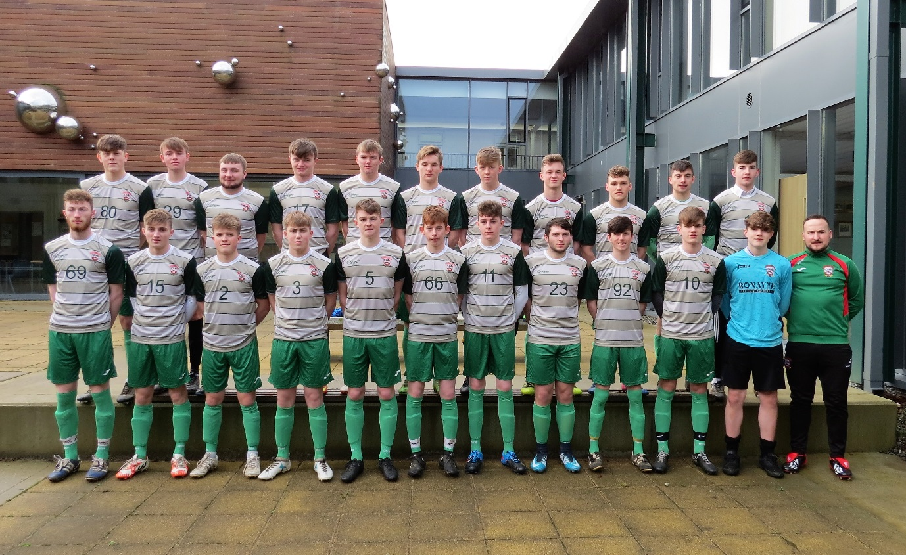
Back Row: Matthew Cleary, Paddy Hayes, Tommy Wells, Stephen Gavin, Michael Kelly, Jack Daly, John O Meara, Cianán O hAnluain, Sean McAdams, Jack Larkin, Mark Carey.
Front Row: Nathan Ryan, Liam Cleary, Kevin Oakley, James Kirk, Conal Moran, Damien Bergin, Mike Heenan, David Ryan, Scott O Brien, Neil Connelly, Eoghan Tinkler.

U17 Soccer squad face their 3rd Munster Final in 3 years.
Borrisokane Community College u17 soccer squad battled ferocious weather conditions with a blinding blizzard on 16th January to beat Bantry CC on a score line of 1.0 to advance to the Munster Final. This is the third final for the school in as many years and hopefully this group of players can emulate the successes of their predecessors in bringing the title back to Borrisokane.

