Booklist 6th Year 2024/2025
Subject | Title | Publisher/Author
Irish  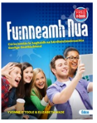 | Fuinneamh Nua (OL)  Fiuntas Nua (HL) | Edco  Edco
English  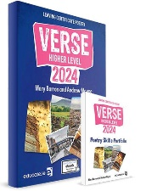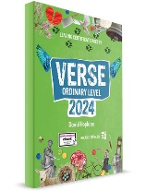 | Verse 2025  King Lear(to be purchased by student) | Educate
Maths  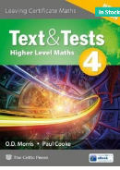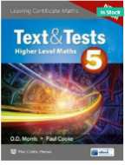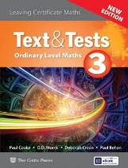 | Text and Tests (HL)  Text & Tests (OL)  Casio Calculator  Maths Tables  Graph Paper | CJ Fallon  CJ Fallon
History | The Making of Ireland ( New Edition)  The Making of Europe and the Wider World(New Edition) | Educate.ie
Geography  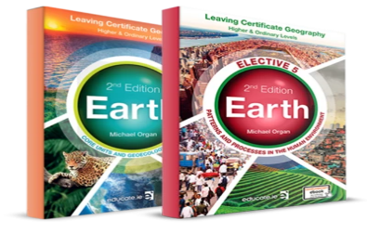 | Earth- 2nd edition textbook and Earth Elective 5(Human)  2 x hardback A4 copies | Educate.ie
Physics  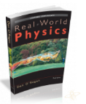 | Real World Physics (New Edition)  Mathematical Tables  Two A4 Hardback Copies ( 1 Science) | O’Regan- Folens
Leaving Cert PE | Peak Performance + Workbook | Folens
Biology  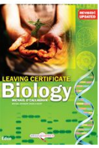 | LC Biology | Michael O’Callaghan- Edco
Chemistry  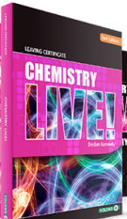 | Chemistry Live  Chemistry Live Workbook  Maths Tables | Folens
Ag Science  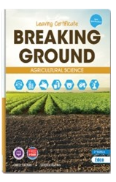 | Breaking Ground New Edition  (New LC Course) | Edco
Art  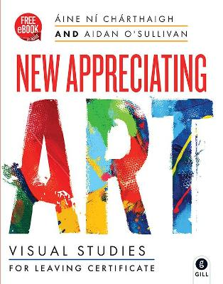 | €10 Art Materials  Appreciating Art(NEW edition) | Gill
Home Economics  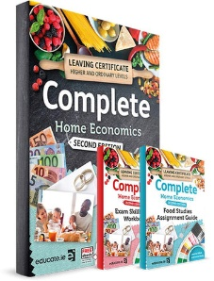 | Complete Home Economics  + Exam Skillbuilder ( New Edition) | Educate.ie
French  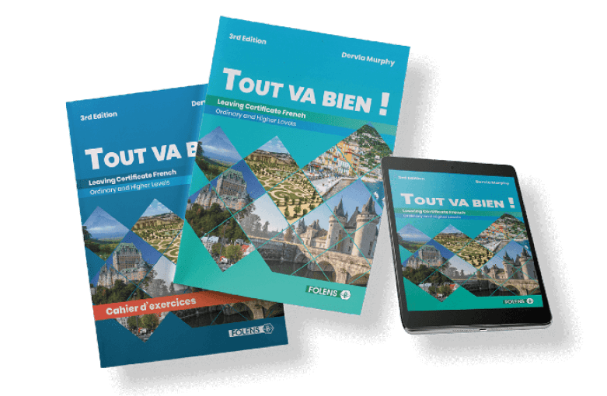 | Tout Va Bien( New Edition) | Folens
German  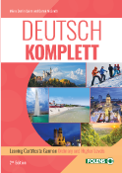 | Deutsch Komplett (New Edition)  German Dictionary | Folens
Construction | Get Constructive + Workbook | Educate.ie
Engineering  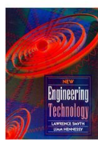 | Engineering Technology | EdCo
DCG | DCG Solutions Workbook (available from school)  Tech Graph Drawing Kit in wood box to be purchased from  sgeducation.ie
Business | Ahead for Business | Educate
Accounting  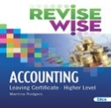 | Revise Wise Accounting  Leaving Cert HL Exam Papers (Edco)  Bookkeeping Calculator can be purchased in Sept | Martina Rodgers Edco
Computer Science  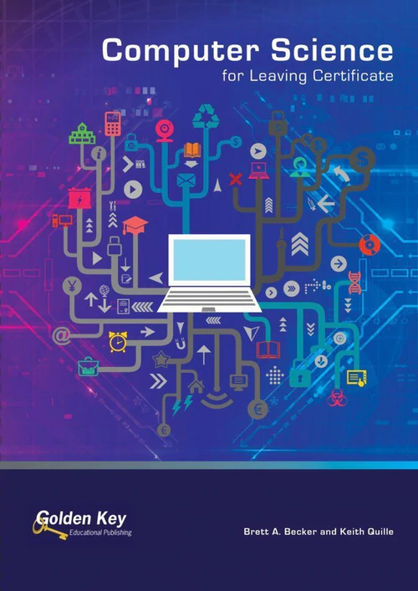 | Computer Science for LC  Hardback Notes copy | Golden Key Publishing
Music | Musical Score of:  Tchaikovsky- Romeo & Juliet Fantasy Overture  Gerard Barry Piano Quartet no 1.  Leaving Cert Music Exam Papers  Music Manuscript  A4 Copy (Paperback)
P.E | PE Uniform available online from www.xgear.ie  Runners for PE should be non-marking. Converse or canvas shoes are not suitable and are unsafe

